All England Badminton Championship: Saina enters finals:
“With this win, she has become the first Indian Woman to enter the final of this prestigious tournament”
PTI, 07-03-15

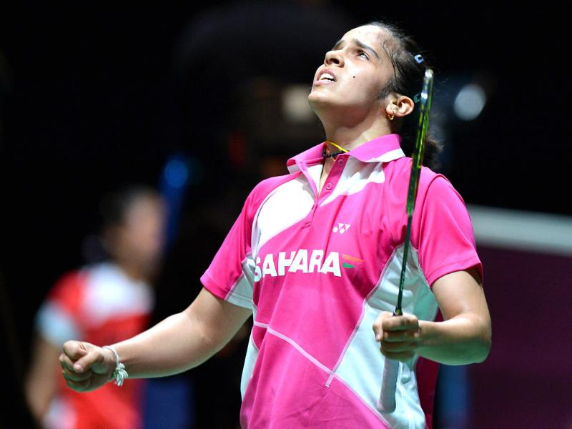
Birmingham: Saina Nehwal has entered the finals of the $500,000 All England Open Badminton Championships at the Barclaycard Arena in Birmingham on Saturday.
Earlier her best performance was a semi-final berth in 2011 and 2013 at the All England championship.
India's ace shuttler Saina Nehwal beat China's unseeded Sun Yu to enter the final of the Women's Singles event in the All England Championships. The third-seeded Indian beat Yu 21-13, 21-13.

Yu put early pressure on Saina, taking a healthy first set lead and maintaining it well. Trailing 3-7 in the first game, Saina made a stunning comeback. The lead was cut down to just two points and Yu crumbled under pressure. Saina stormed back into the lead at 13-11. She eventually won the first game 21-13.
The second game started in similar fashion with Sun taking an early two-point lead. Sun kept the pressure on Saina to cling on to her lead at 9-7. Saina soon wiped out that slender lead and even went ahead by two points at 14-12. There was no way back for Sun as Saina eventually clinched the match 21-13.
Earlier, Saina Nehwal got the better of China’s former World Champion Yihan Wang 21-19, 21-6 to march into the Semifinals.
Saina Nehwal will play the winner of second Semi-final match between Spaniard Carolina Marin and Taipei’s Tai Tzu Ying in the Women’s Singles title clash.
----------------------------------------

